**EXPERIMENT NO –12:**

**IOT BASED SMART GARDEN USING CISCO PACKET TRACER.**

**AIM:**

**The main aim is to build an smart graden based on the iot systems.**

**Materials required:: Cisco tracer software,water sprinkler ,water level monitor.**

Procedure ::

1.open the cisco tracer .

2.Then ,network devices-wireless devices-homegateway and place it on the site.

3.then ,end devices—home—lawn sprinkler -and waterlevel monitor and other garden appliences.

4.then set them as bellow

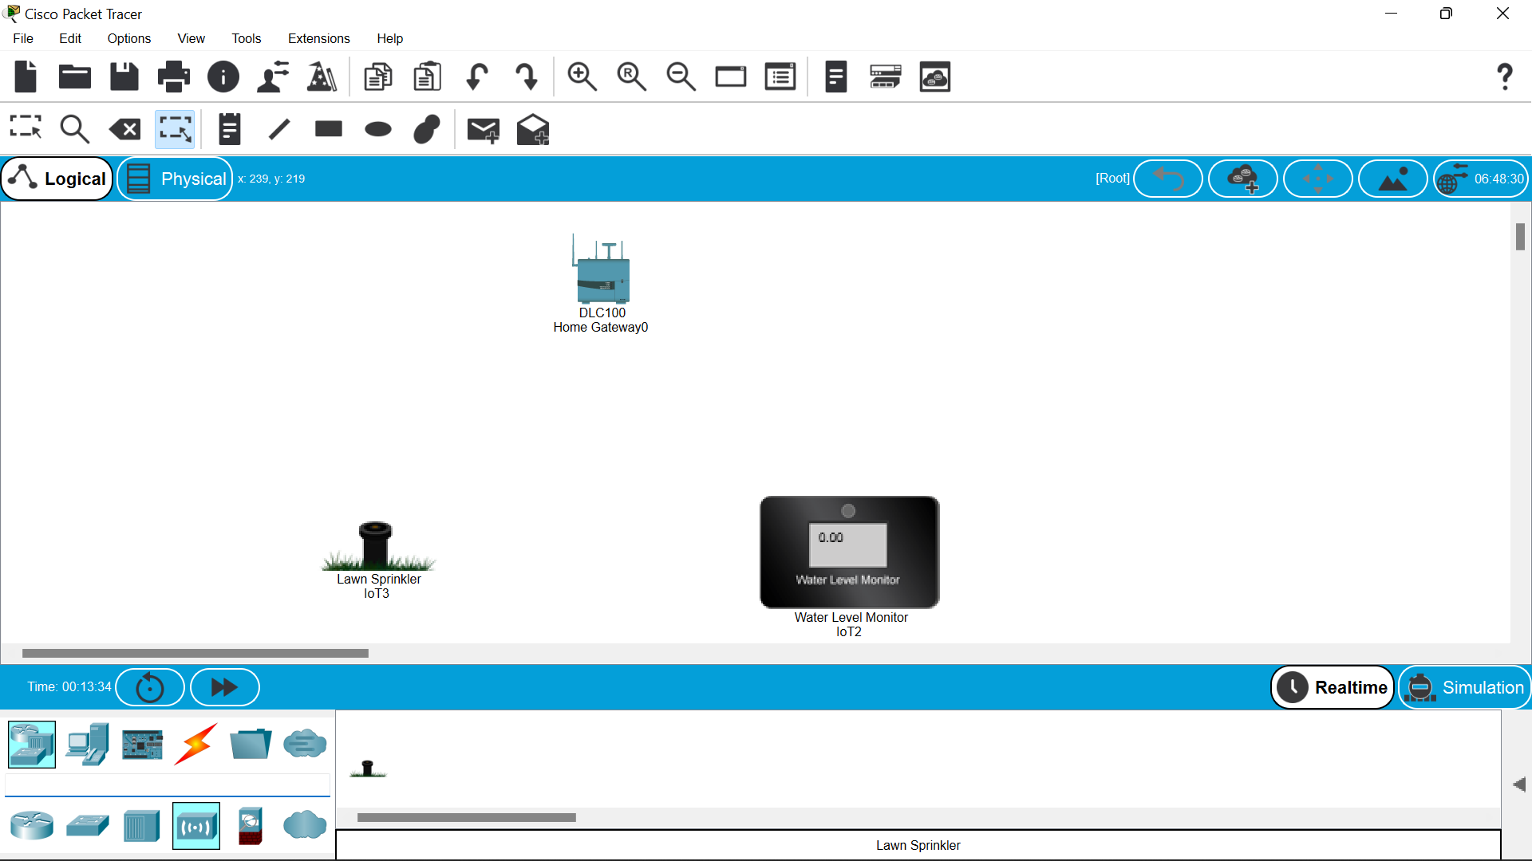

5.then click on the lawn sprinkler-i/o configure –choose the wireless –then configuration and wireless0 .repeat the same to the water level monitor also,then the dotted lines will be formed btwn the homegatway and lawn water sprinkler and water level minotor.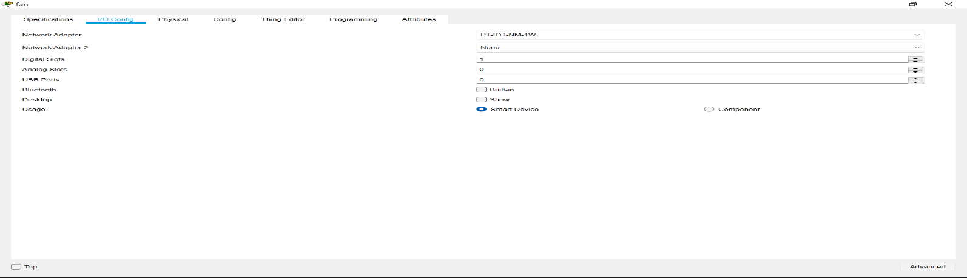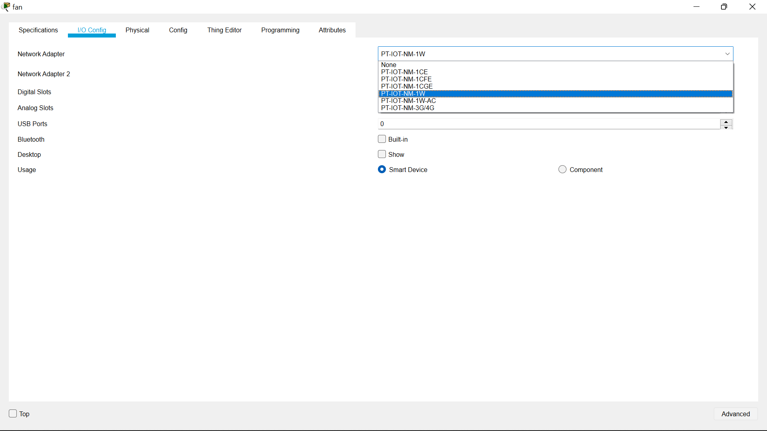

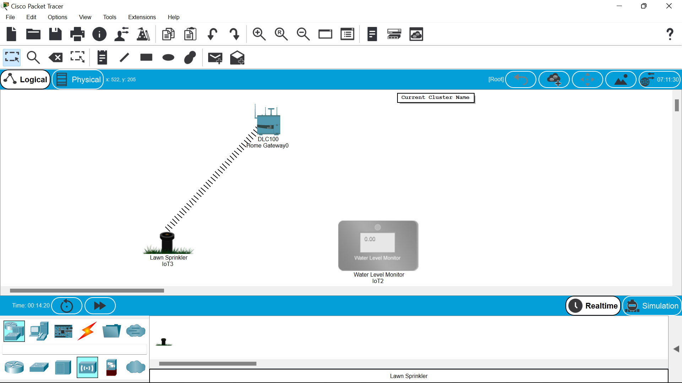

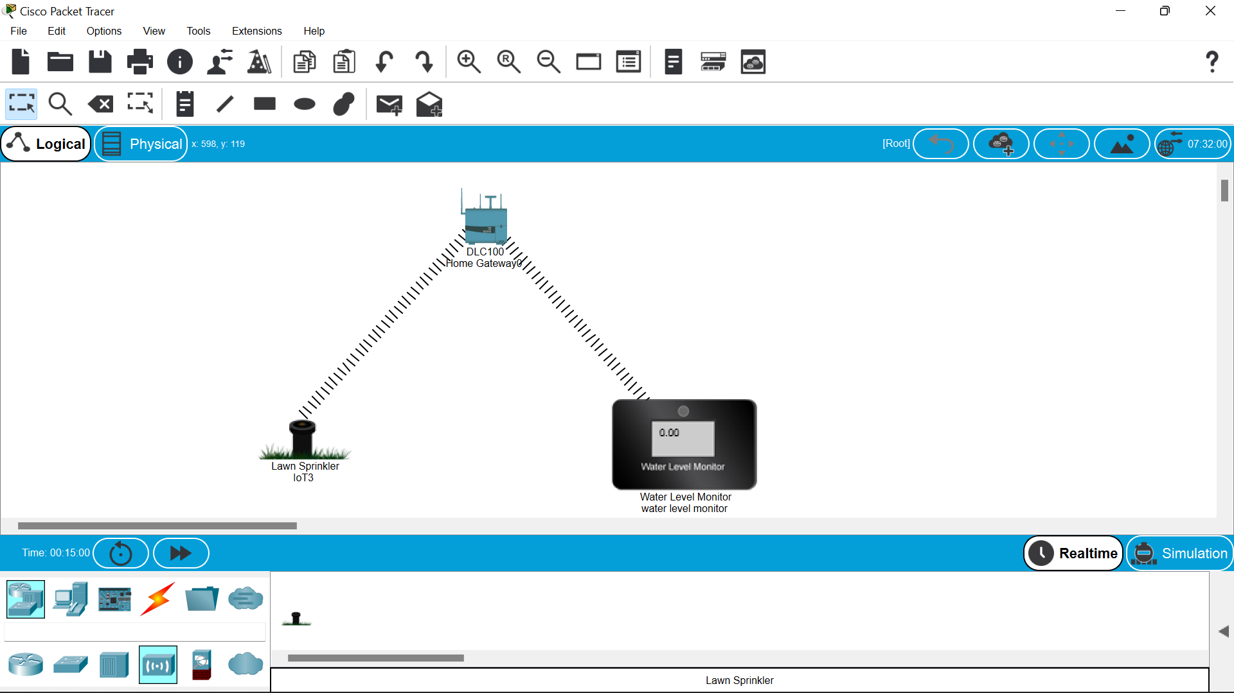

6.Then move to the end devices –click the smartphone to operate the wireless devices.

7.click on the smart phone to configure with homegateway give “HomeGateway” in the ssid space in wireless0.

8.connetion is established 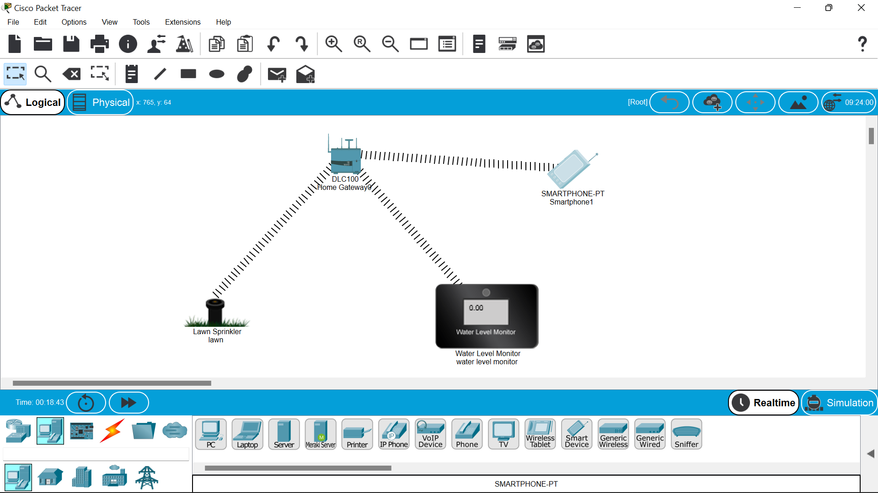

9.then click on the smart phone open desktop –iot monitor—login.

10.then you will find switches of lawn sprinkler and the waterlevel monitor is also displayed but it will run automatically when ever we switch on the lawn sprinkler .

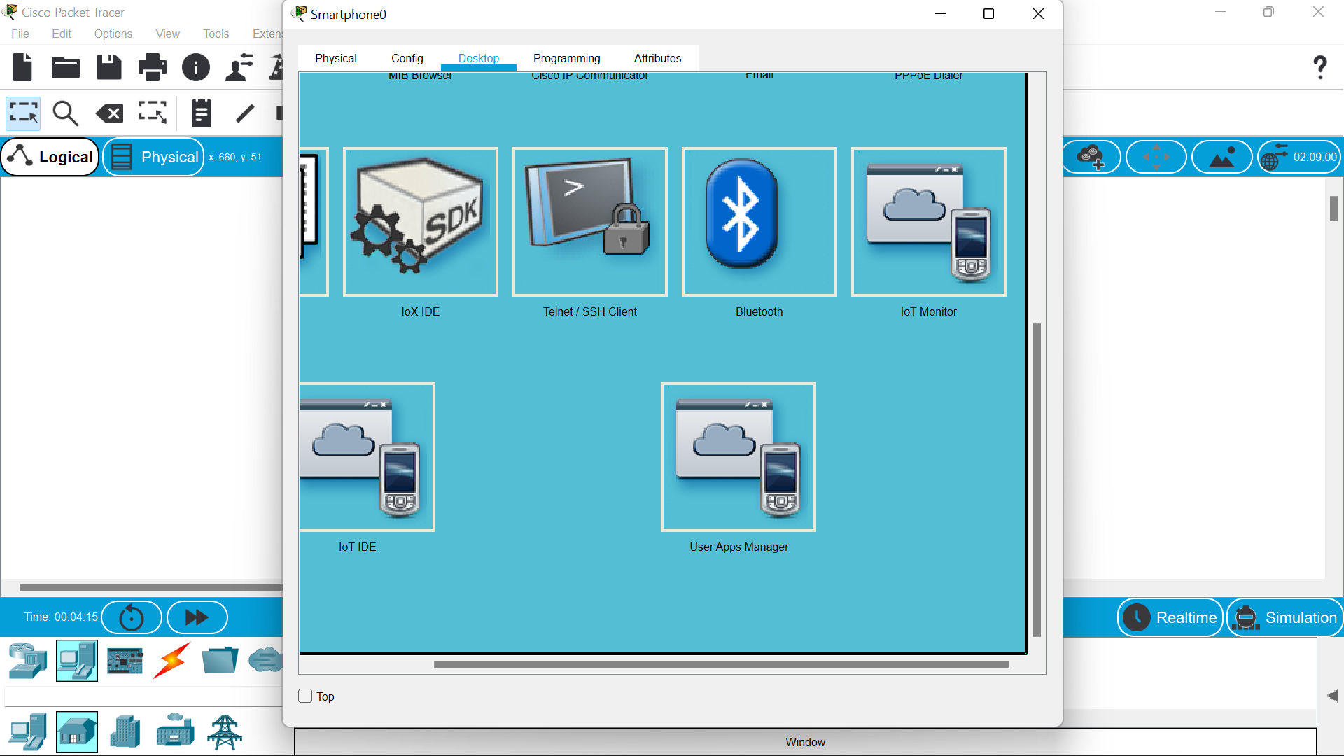

11.below are the switches to access the lawn sprinkler by which automatically the water level monitor will also be turned on.

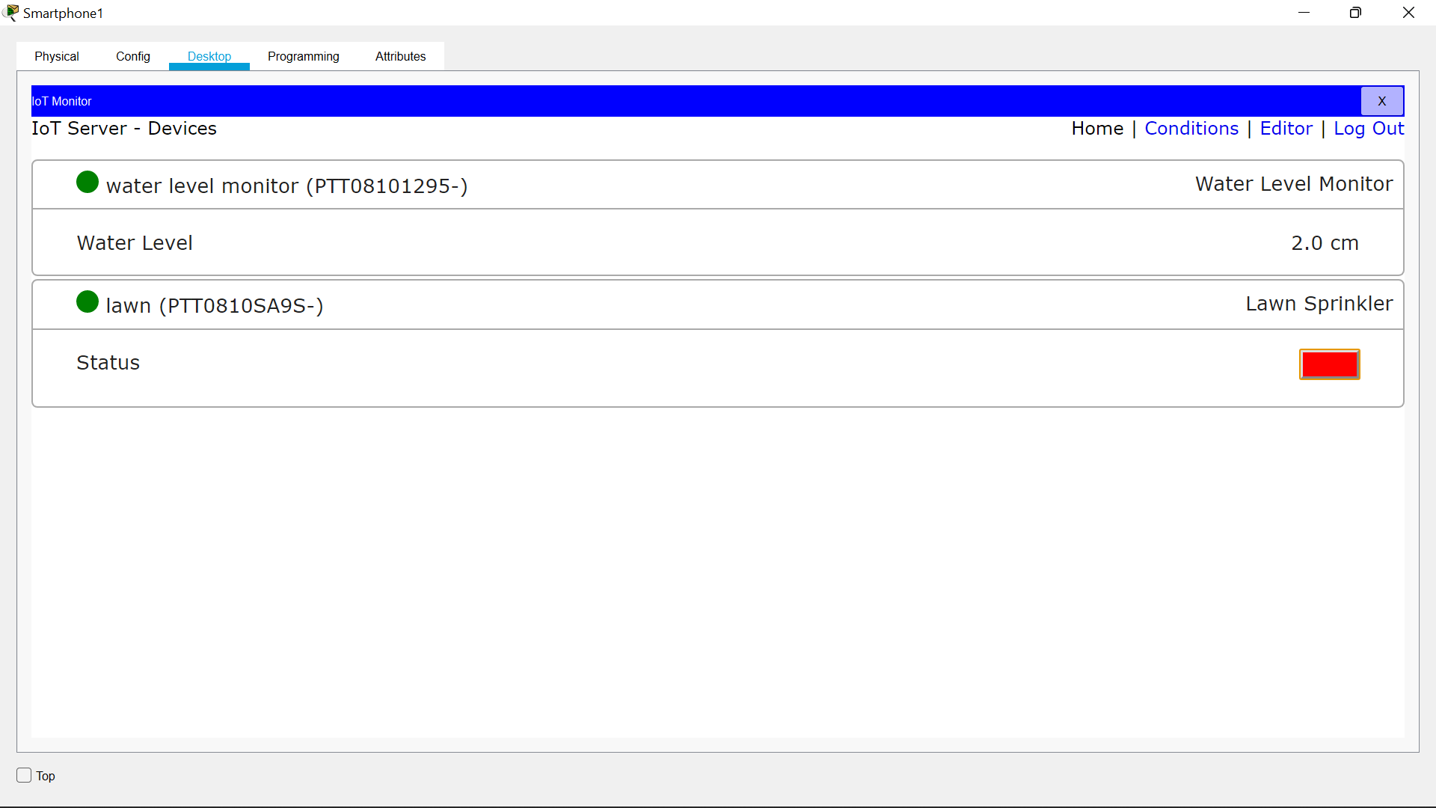

12.finally the lawn will be sprinkilling the water as in a garden.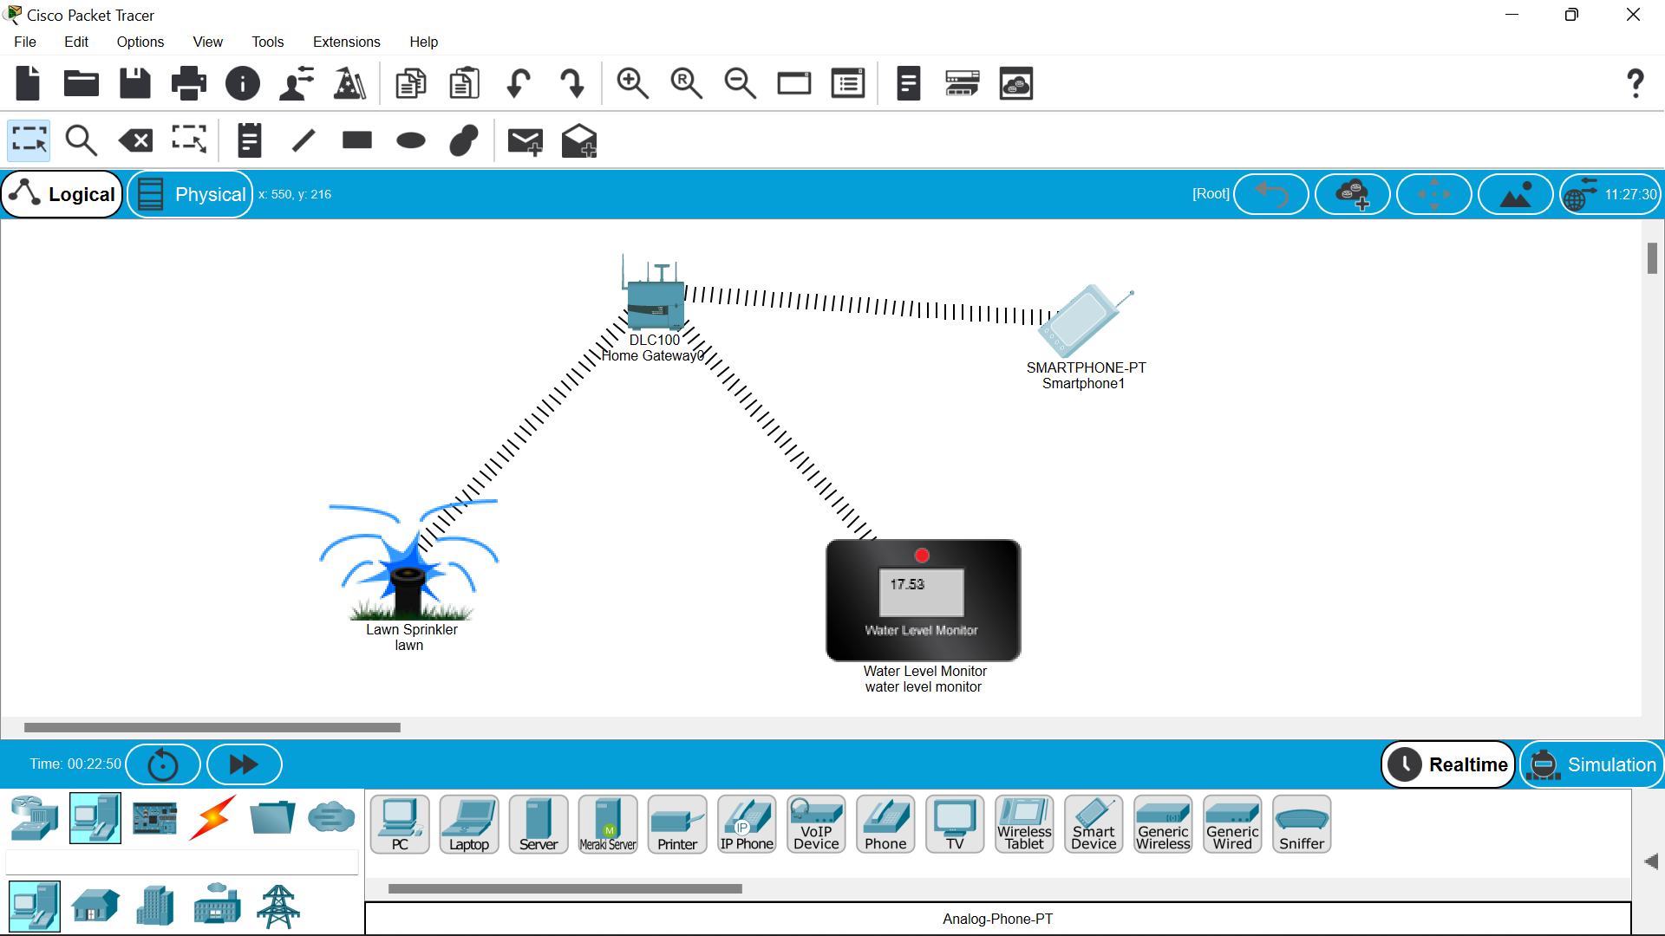

RESULT::

There fore the smart garden has been designed by the cisco packet racer successfully……..